**ECON300 Fundamentals of Economics**

**Homework 2**

**Note:** 50 points in total.

NAME:__________ ID: ____________________

**I. Multiple Choices (1 pt each)**

1) Marginal utility is the

A) total satisfaction received from consuming a given number of units of a product.

B) average satisfaction received from consuming a product.

C) extra satisfaction received from consuming one more unit of a product.

D) satisfaction achieved when a consumer has had enough of a product.

2) If a consumer receives 20 units of utility from consuming two candy bars, and 25 units of utility from consuming three candy bars, the marginal utility of the third candy bar is

A) 25 utility units.

B) 20 utility units.

C) 5 utility units.

D) unknown as more information is needed to determine the answer.

3) Which of the following is likely to occur as the result of the law of diminishing marginal utility?

A) Petra's utility from her second apple was less than her satisfaction from her first orange.

B) Hudson enjoyed his second slice of pizza more than his first.

C) Sabine's utility from her first granola bar is greater than Rachel's utility from her second granola bar.

D) Wesley enjoyed his second bottle of iced tea less than his first bottle, other things constant.

4) Price elasticity of demand measures

A) how responsive suppliers are to price changes.

B) how responsive sales are to changes in the price of a related good.

C) how responsive quantity demanded is to a change in price.

D) how responsive sales are to a change in buyers' incomes.

5) The price elasticity of demand for Stork ice cream is -4. Suppose you're told that following a price increase, quantity demanded fell by 10 percent. What was the percentage change in price that brought about this change in quantity demanded?

A) 40 percent

B) 25 percent

C) 2.5 percent

D) 0.4 percent

6) Jenna runs a small boutique in Capitola. She tells one of her suppliers that she is willing to pay $6 for a pair of wool hand warmers and not a dime more. On the basis of this information, what can you conclude about her price elasticity of demand for wool hand warmers?

A) It is elastic.

B) It is perfectly elastic.

C) It is perfectly inelastic.

D) The price elasticity coefficient is 0.

***Figure 7-4***

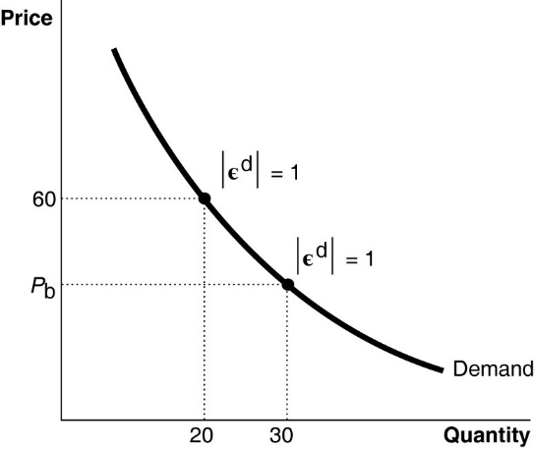

7) ***Refer to Figure 7-4.*** The absolute value of the price elasticity of demand at points *a* and *b* is 1. What is the value of *P*b? Use midpoint formula.

A) $50

B) $40

C) $30

D) $20

8) Jaycee Jeans sold 40 pairs of jeans at a price of $40. When it lowered its price to $20, the quantity sold increased to 60 pairs. Calculate the absolute value of the price elasticity of demand. Use the midpoint formula.

A) 1.67

B) 1.0

C) 0.6

D) 0.53

9) Which of the following statements about price elasticity of demand is *false*?

A) The value of the price elasticity of demand is the reciprocal of the value of the demand curve's slope.

B) If quantity demanded changes by a larger percentage than the percentage change in price, demand is elastic.

C) The value of the price elasticity of demand along a downward-sloping demand curve is always negative.

D) A linear downward-sloping demand curve has a varying price elasticity coefficient.

10) The price elasticity of demand for beef is estimated to be 0.60 (in absolute value). This means that a 20 percent increase in the price of beef, holding every thing else constant, will cause the quantity of beef demanded to

A) decrease by 12 percent.

B) decrease by 26 percent.

C) decrease by 32 percent.

D) decrease by 60 percent.

11) Which of the following statements about the price elasticity of demand iscorrect?

A) The elasticity of demand for a good in general is equal to the elasticity of demand for a specific brand of the good.

B) The absolute value of the elasticity of demand ranges from zero to one.

C) Demand is more elastic in the long run than it is in the short run.

D) Demand is more elastic the smaller the percentage of the consumer's budget the item takes up.

12) When there few close substitutes available for a good, demand tends to be

A) perfectly inelastic.

B) perfectly elastic.

C) relatively inelastic.

D) relatively elastic.

13) According to a study of the price elasticities of products sold in supermarkets, the price elasticity of demand for toothpaste is estimated at -0.45. Which of the following could explain why the price elasticity of demand for toothpaste is so low?

A) The toothpaste industry is highly competitive.

B) Toothpaste is relatively inexpensive.

C) Toothpaste is heavily endorsed by dentists.

D) There are few close substitutes for toothpaste.

14) Which of the following is an example of positive technological change?

A) A firm offers workers a higher wage to work on weekends and at night. As a result, the firm is able to increase its weekly production of surf boards.

B) A firm buys an additional machine that it uses to make surf boards. As a result, the firm is able to increase its weekly production of surf boards.

C) A firm conducts a new advertising campaign. As a result, the demand for the firm's surf boards increases.

D) A firm's workers participate in a training program designed to increase the number of surf boards they can produce per day.

15) If a producer is not able to expand its plant capacity immediately, it is

A) bankrupt.

B) operating in the long run.

C) operating in the short run.

D) losing money.

16) Which of the following is a fixed cost?

A) payment to hire a security worker to guard the gate to the factory around the clock

B) wages to hire assembly line workers

C) payments to an electric utility

D) costs of raw materials

17) Vipsana's Gyros House sells gyros. The cost of ingredients (pita, meat, spices, etc.) to make a gyro is $2.00. Vipsana pays her employees $60 per day. She also incurs a fixed cost of $120 per day. Calculate Vipsana's **average fixed cost** per day when she produces 50 gyros using two workers?

A) $2.00

B) $2.40

C) $4.40

D) $6.80

18) In the long run which of the following is *true*?

A) Total cost = fixed cost + variable cost.

B) The size of a firm's physical plant can be changed but the firm cannot adopt new technology.

C) There are no fixed costs.

D) The firm can vary its explicit costs but not its implicit costs.

19) Bill owns "Bill's Home of Blues" a store that specializes in selling CDs and DVDs of blues musicians of the 1960s and 1970s. Bill took out a loan from his bank to pay for his store and its initial inventory. Bill pays the bank $900 per week for his loan. The $900 bank payment

A) is a long-run implicit cost.

B) is a fixed cost.

C) is a short-run implicit cost.

D) is a variable cost.

20) The marginal product of labor is defined as

A) the additional sales revenue that results when one more worker is hired.

B) the additional output that results when one more worker is hired, holding all other resources constant.

C) the additional number of workers required to produce one more unit of output.

D) the cost of hiring one more worker.

21) The law of diminishing marginal returns

A) explains why the average total cost and marginal cost curves are U-shaped in the short run.

B) explains why the average total cost, average fixed cost and the marginal cost curves are U-shaped in the short run.

C) causes average total costs to rise at a decreasing rate as output increases.

D) causes the difference between average total cost and average variable cost to get smaller as output increases.

22) One reason why, in the short run, the marginal product of labor might increase initially as more workers are hired is that

A) the first workers hired get to use the best equipment.

B) specialization allows a worker to focus on one task, thereby increasing her proficiency at that task.

C) the best workers are hired first and later hires are not as skillful.

D) beyond some point, a firm has hired too many workers.

23) If we have information about workers' marginal products, then total and average product can be found by

A) dividing marginal costs by the number of workers.

B) multiplying the average marginal product times the number of workers.

C) summing the marginal values to find the total and multiplying it times the number of workers to get the average.

D) summing the marginal values to find the total and dividing it by the number of workers to get the average.

24) Which of the following statements is *true*?

A) The average product of labor is at its maximum when the average product of labor equals the marginal product of labor.

B) The average product of labor is at its minimum when the average product of labor equals the marginal product of labor.

C) The average product of labor tells us how much output changes as the quantity of workers hired changes.

D) Whenever the marginal product of labor is greater than the average product of labor the average product of labor must be decreasing.

25) The marginal product of labor is calculated using the formula

A) *L*/*Q*.

B) Δ*L/*Δ*Q.*

C) Δ*Q/*Δ*L.*

D) *Q/*L.

26) When the marginal product of labor rises

A) the marginal cost of production will exceed the average total cost.

B) the marginal cost of production also rises.

C) the marginal cost of production falls.

D) the average total cost of production also rises.

27) Long-run cost curves are U-shaped because

A) of the law of demand.

B) of the law of diminishing returns.

C) of economies and diseconomies of scale.

D) of the law of supply.

28) Over the past twenty years, the number of small family farms has fallen significantly and in their place there are fewer, but larger, farms owned by corporations. Which of the following best explains this trend?

A) diseconomies of scale in farming

B) economies of scale in farming

C) diminishing returns to labor in farming

D) declining productivity

**II. Essays (2 pts each)**

***Figure 8-1***(1 pt for each question, 5 pts total)

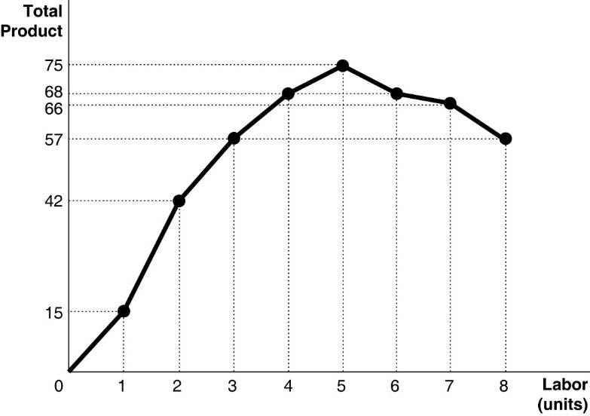

1) ***Refer to Figure 8-1.*** What is the marginal product of the 3rd worker?

- 15 products

2) ***Refer to Figure 8-1.*** Diminishing marginal productivity sets in after

A) the 2nd worker is hired.

B) the 3rd worker is hired.

C) the 4th worker is hired.

D) the 5th worker is hired.

3) ***Refer to Figure 8-1.*** In a diagram that shows the marginal product of labor on the vertical axis and labor on the horizontal axis, the marginal product curve

A) never intersects the horizontal axis.

B) intersects the horizontal axis at a point between the 5th worker and the 6th worker.

C) intersects the horizontal axis at a point corresponding to the 6th worker.

D) intersects the horizontal axis at a point corresponding to the 8th worker.

***Table 7-2***

|  |  |  |  |  |  |  |  |
| --- | --- | --- | --- | --- | --- | --- | --- |
| **Quantity of Soup (cups)** | **Total Utility** | **Quantity of Sandwiches** | **Total Utility** | **MUsp** | **MUsa** | **MUsp/Psp** | **Musa/Psa** |
| 1 | 40 | 1 | 45 | 40 | 45 | 20 | 15 |
| 2 | 60 | 2 | 75 | 20 | 30 | 10 | 10 |
| 3 | 72 | 3 | 102 | 12 | 27 | 6 | 9 |
| 4 | 82 | 4 | 120 | 10 | 18 | 5 | 6 |
| 5 | 88 | 5 | 135 | 6 | 15 | 3 | 5 |
| 6 | 90 | 6 | 145 | 2 | 10 | 1 | 10/3 |

Table 7-2 above shows Keira's utility from soup and sandwiches. The price of soup is $2 per cup and the price of a sandwich is $3. Keira has $18 to spend on these two goods.

4) ***Refer to Table 7-2***. What is Keira's marginal utility per dollar spent on the third cup of soup?

- Keira's marginal utility per dollar spent on the third cup of soup is 6

5) ***Refer to Table 7-2.*** If Keira maximizes her utility, how many units of each good should she buy?

- She should buy 3 cups of soup and 4 sandwiches.

6) ***Refer to Table 7-2.*** Suppose Keira's income increases from $18 to $23 but prices have not changed. What is her utility maximizing bundle now?

- Her utility maximizing bundle now is 4 cups of soup and 5 sandwiches

7) ***Refer to Table 7-2.*** Holding prices constant, when Keira's income changed from $18 to $23, her utility maximizing bundle changed. Based on your answers to her optimal choices at the two income levels, what type of goods are soup and sandwiches, i.e., are they normal or inferior goods?

- They are normal goods

8) ***Refer to Table 7-2.*** Holding prices constant, when Keira's income changed from $18 to $23, what happens to her total utility and to the marginal utilities of the last cup of soup and the last sandwich purchased?

A) Her total utility increases but the marginal utilities of the last cup of soup and the last sandwich consumed decrease.

B) Her total utility, the marginal utility of the last cup of soup consumed and the marginal utility of the last sandwich consumed, all increase.

C) Her total utility decreases but the marginal utilities of the last cup of soup and the last sandwich consumed increase.

D) Her total utility and the marginal utility of the last cup of soup consumed increase but marginal utility of the last sandwich consumed decreases.

E) Her total utility and the marginal utility of the last sandwich consumed increase but marginal utility of the last cup of soup consumed decreases.

***Figure 7-8***

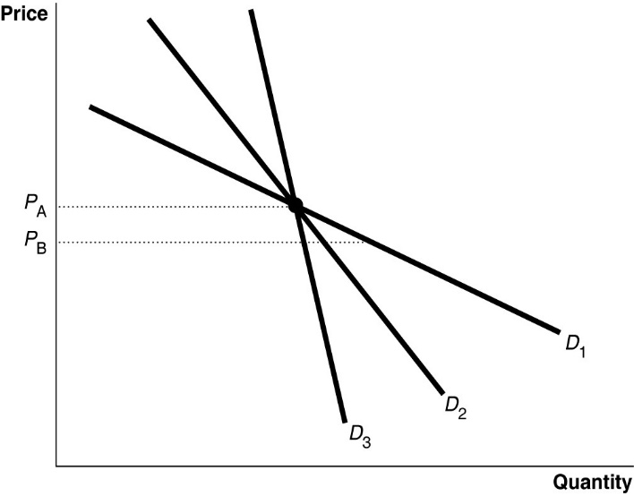

9) ***Refer to Figure 7-8.*** As price falls from *P*A to *P*B, the quantity demanded increases most along *D*1; therefore,

A) *D*1 is unit elastic.

B) *D*1 is more inelastic than *D*2 or *D*3.

C) *D*1 is more elastic than *D*2 or *D*3

D) *D*1 is elastic at *P*A but inelastic at *P*B.

10) Suppose the price of gasoline in July 2004 averaged $1.35 a gallon and 15 million gallons a day were sold. In October 2004, the price averaged $2.15 a gallon and 14 million gallons were sold. If the demand for gasoline did not shift between these two months, **use the midpoint formula** to calculate the price elasticity of demand. Indicate whether demand was elastic or inelastic.

- The price elasticity of demand:

- Demand was inelastic

11) The current price of canvas messenger bags is $36 each and sales of the bags equal 400 per week. If the price elasticity of demand is -2.5 and the price changes to $44, how many messenger bags will be sold per week? **Use the midpoint formula**.

* 240 messenger bags will be sold